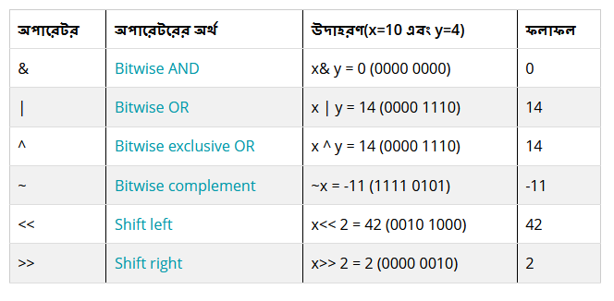

Bitwise Operator: Recsource link: https://www.sattacademy.com/cprogramming/bitwise_operators.php